Raiteas Misin – Gaelscoil Thomais Dáibhís
“Mol an óige is tiocfaidh sí”
Is gaelscoil Chaitliceach í seo, ina gcuirtear gaelscolaíocht d’ardchaighdeán ar fáil dár bpáistí agus ina cothaítear meas agus tuiscint ar a chéile, ar ár difríochtaí agus ar ár gcosúlachtaí. Déantar é seo i dtimpeallacht Ghaelach a chuireann béim ar ár n-oidhreacht agus ár gcultúr.

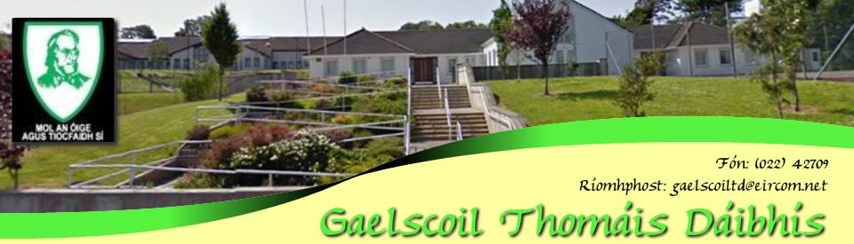

“Praise the youth and she will prosper”
As a catholic gaelscoil our mission is to provide a high standard of education through the medium of Irish to all our children and to cultivate respect and understanding for each other, our differences and our similarities. We strive to achieve this in an environment that nurtures children’s love of our Irish culture.

